1.MySQL LIKE condition:

**Using % (percent) Wildcard:**

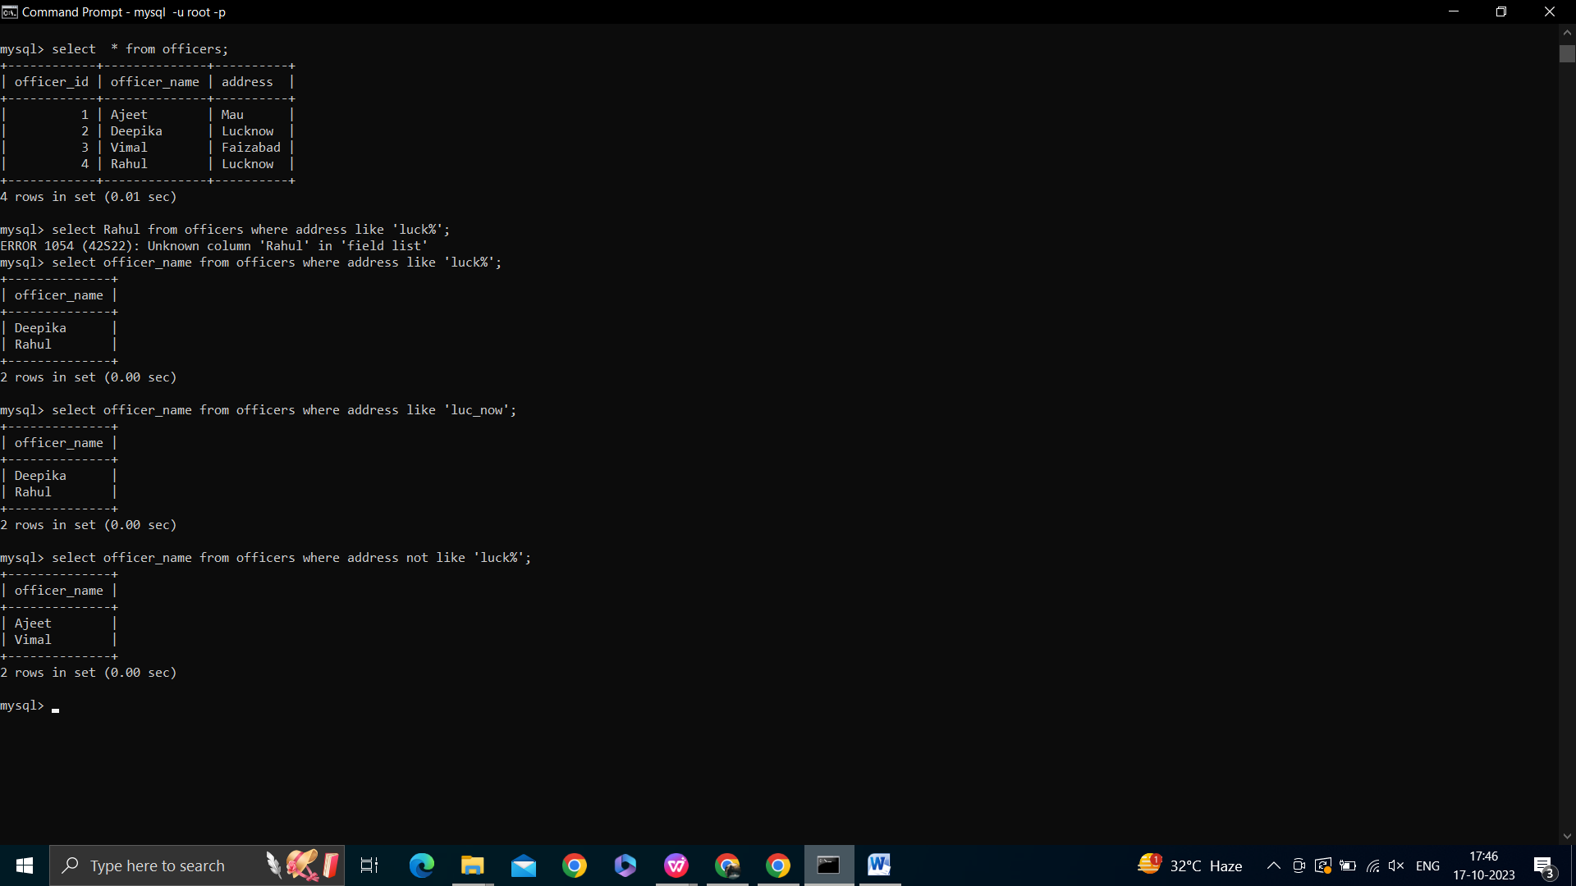



**Using _ (Underscore) Wildcard:**

Using NOT Operator:



**2.MySQL IN Condition;**

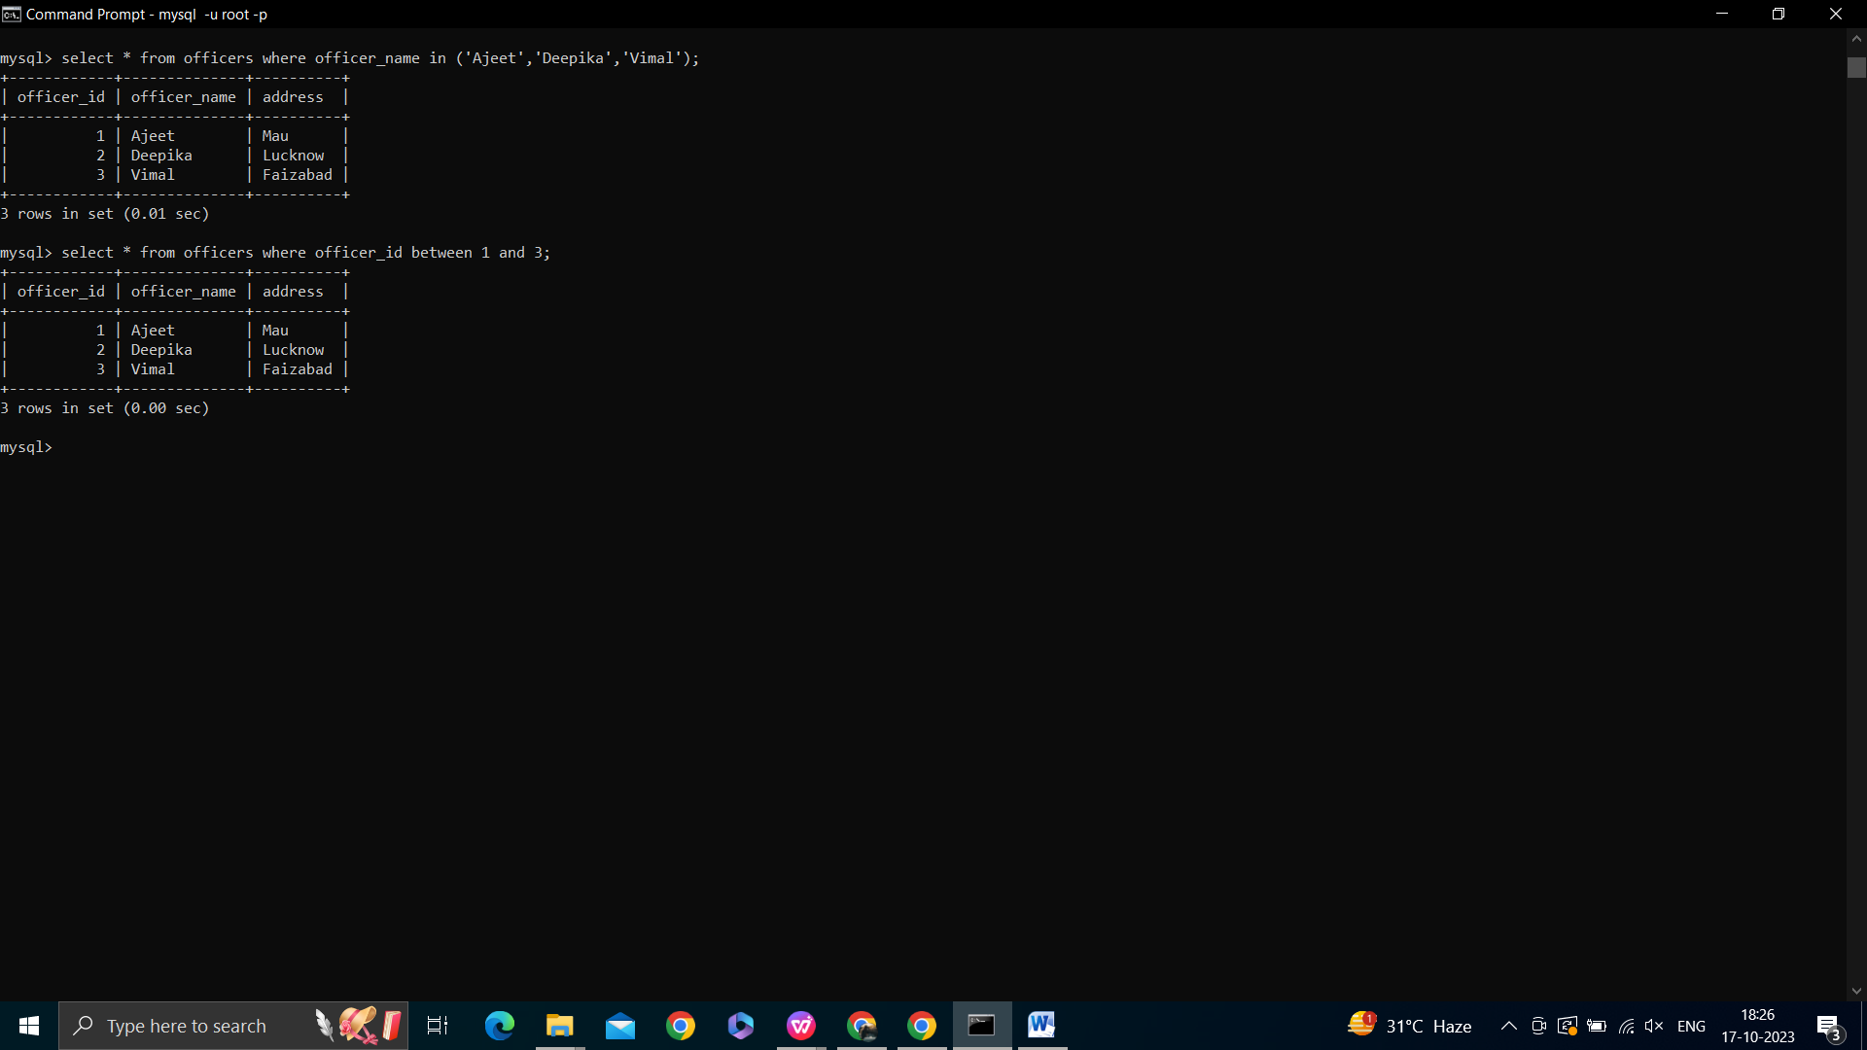

**3. MySQL BETWEEN Condition**



**4. MySQL BETWEEN condition with date:**

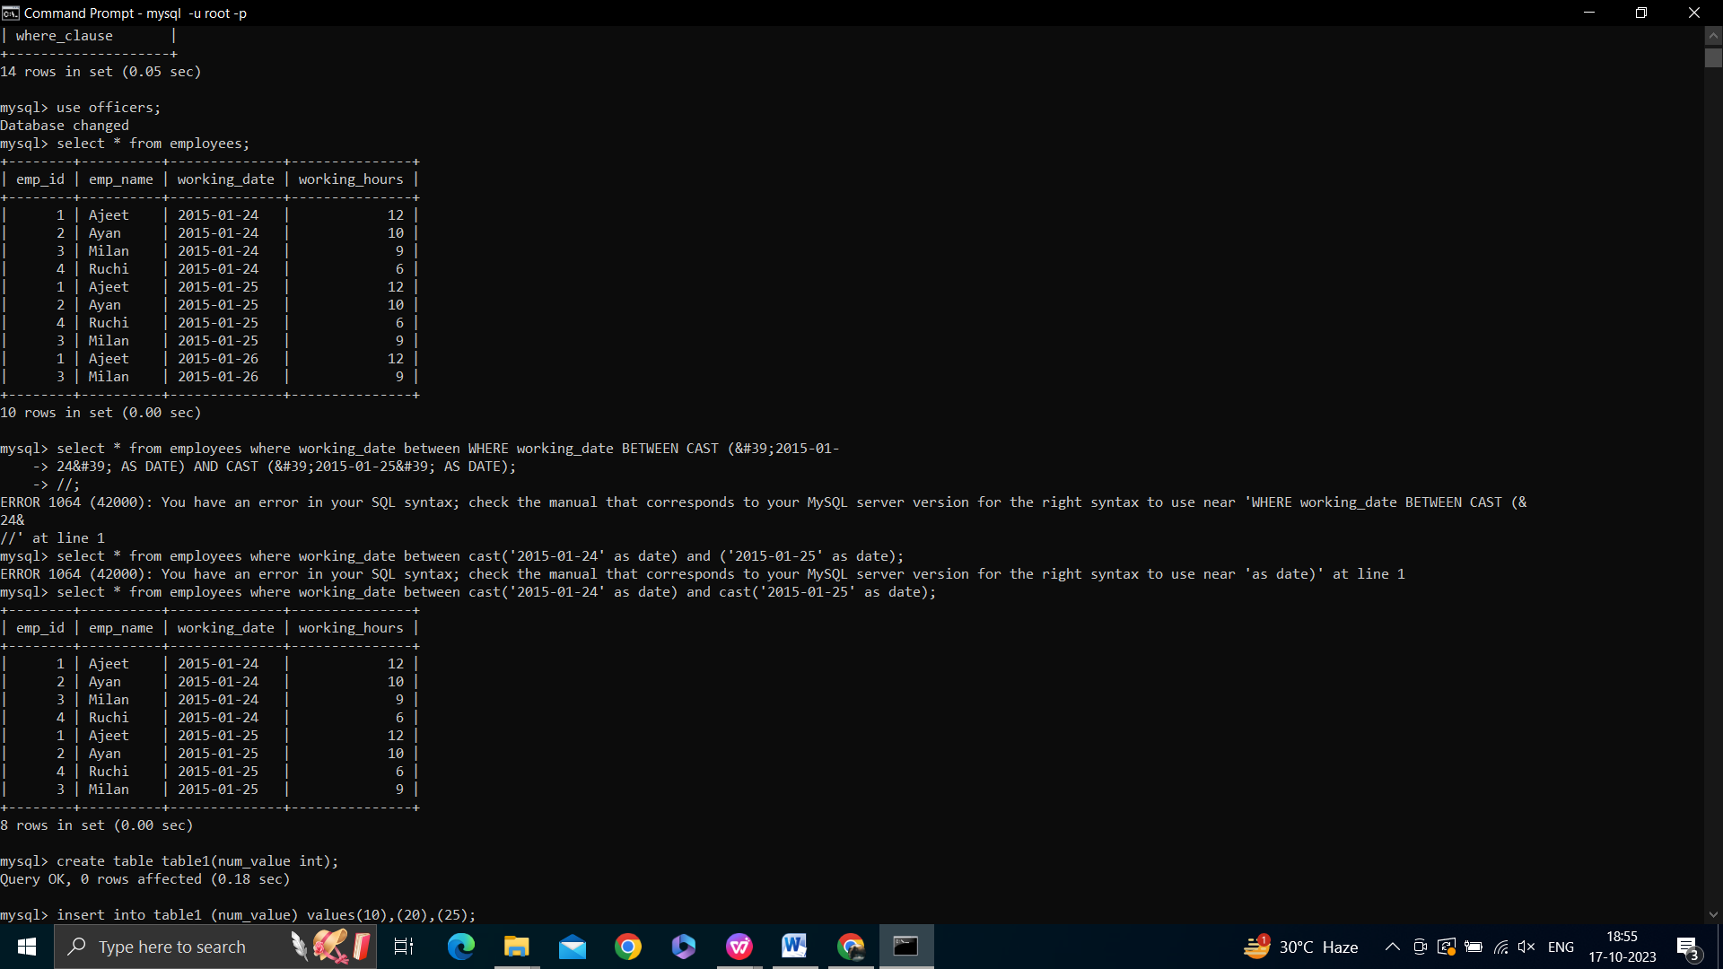



**5.MySQL ANY**

